JANUARY-JUNE 2024 AT A GLANCE  Fresh Audio & Video  - Over 100 more podcasts posted in Douglas’s series.  - Naomi series (Vicki’s podcast series, Women of Worth)  - Conversations (4) (Douglas and Vicki)—honest reflections on church and the state of the church today.  - Interview (Conversation 17): Nadine Templer (Kathmandu, Nepal): “Positive Perspectives on Politics, Poverty, Parenting, & Church People”  - Online communion services (26), including 13 guest messages from the UK, US, and Australia. Speakers in the second half of 2024 are from Brazil, South Africa, Nigeria, US, Kuwait, Ireland, and several other countries.  New resources through the website  - Living N.T. Commentary—1100 pages of commentary on every verse of the N.T. constantly updated.  - Book downloads: Ezekiel (text and audio) and Islam.  - Fair Havens: a ministry of hope for the discouraged or disillusioned. Our goal: to help them stay anchored in the Lord and his Word.  Biblical training  - AIM (US mainland): 2 sessions (online)  - AIM UK: 2 sessions (on-site)  - European School of Missions (Worldviews, December-March)—with students from around Western Europe  - Tuition assistance (graduate degrees): over $11,000  - Training, mentoring, or encouraging scores of teachers and teachers-in-training. These 80-90 brothers and sisters live and work on every inhabited continent.  Christian teaching materials provided  - Saudi Arabia ($1643), United Arab Emirates ($3236), Qatar ($1040), Bahrain ($438), Oman ($140), Jordan ($418), Kuwait ($1000)  - Sierra Leone ($317), Uganda: Kayunga church planting—Bibles ($791), Uganda medical needs ($26), Nigeria: Jos ($2696), Nigeria: Lagos ($1825)  - Sri Lanka & India $170), Turkey ($47), Jordan ($65), Bangladesh: Khagracchari ($233), India: general ($465), Philippines ($83), Sri Lanka: Colombo ($1783), Nepalese school ($8000)  - Jamaica ($65), Estonia ($73), Colombia ($96) | 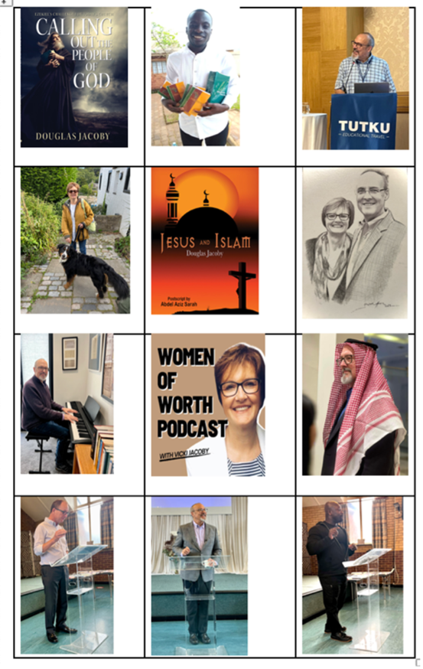  Ezekiel book (free download), grateful recipient of Bibles (Uganda), June 2024 Antioch Seminar, Vicki & Darcy, Islam book (free download), sketch (younger years), our keyboard, Vicki’s podcast, in Saudi Arabia, AIM UK-I teaching with Malcolm Cox and Andrew Boakye  Jan-Jun 2024 Teaching trips  - Iceland  - Saudi Arabia and the United Arab Emirates  - Italy  - Turkey  - United States x2 (Texas, Georgia)  - United Kingdom (Morecambe, Manchester x2, Aberdeen, AIM x2)  - The Antioch Seminar (Turkey), June 2024, with 20 sponsored guests from Asia, South America, America, Europe, the Caribbean, and the Middle East.  - Upcoming: US x2, Sri Lanka, China

